Assignment 1

1. Python program to print calender

Code:

# Program to display calendar of the given month and year

# importing calendar module

import calendar

yy = 2021 # year

mm = 01 # month

# To take month and year input from the user

# yy = int(input("Enter year: "))

# mm = int(input("Enter month: "))

# display the calendar

print(calendar.month(yy, mm))

Output:

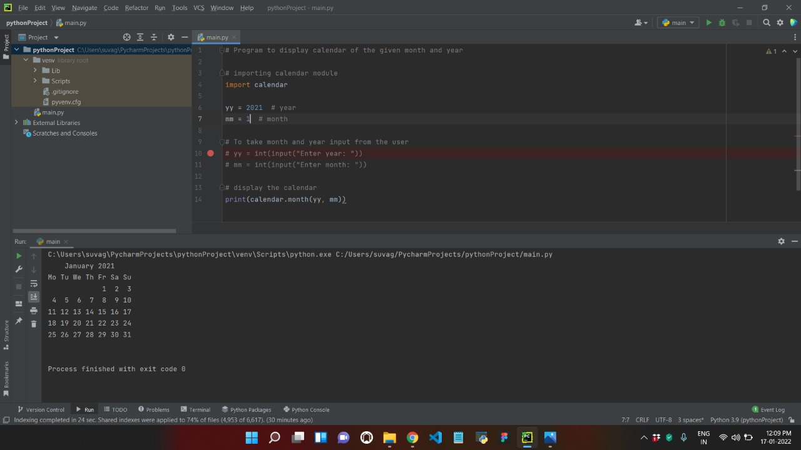

2. Python program to find Cube of a Number

Code:

# Python Program to Calculate Cube of a Number

number = float(input(" Please Enter any numeric Value : "))

cube = number * number * number

print("The Cube of a Given Number {0} = {1}".format(number, cube))

Output:

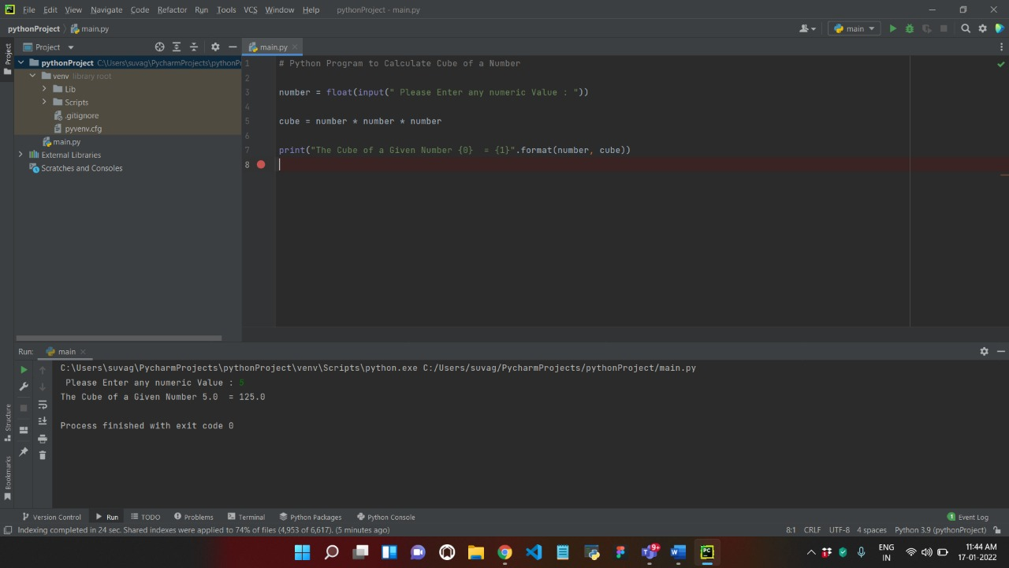

3. Python program to find Largest of 3 Number.

Code:

# Python program to find the largest number among the three input numbers

# change the values of num1, num2 and num3

# for a different result

num1 = 10

num2 = 14

num3 = 12

# uncomment following lines to take three numbers from user

#num1 = float(input("Enter first number: "))

#num2 = float(input("Enter second number: "))

#num3 = float(input("Enter third number: "))

if (num1 >= num2) and (num1 >= num3):

largest = num1

elif (num2 >= num1) and (num2 >= num3):

largest = num2

else:

largest = num3

print("The largest number is", largest)

Output:

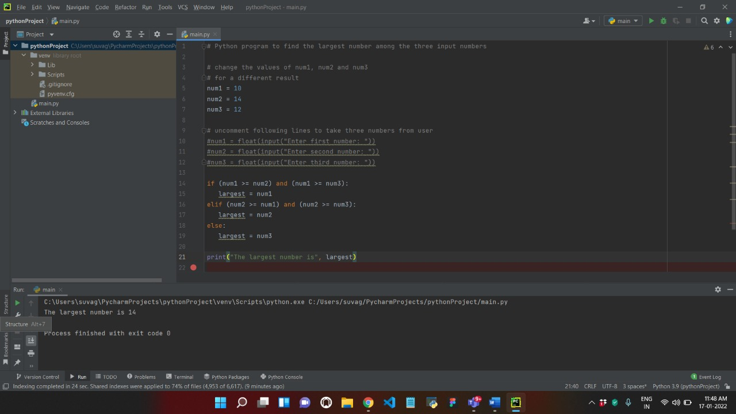

4. Python program to print Natural number 1 to N.

Code:

# Python Program to Print Natural Numbers from 1 to N

number = int(input("Please Enter any Number: "))

print("The List of Natural Numbers from 1 to {0} are".format(number))

for i in range(1, number + 1):

print(i, end=' ')

Output:

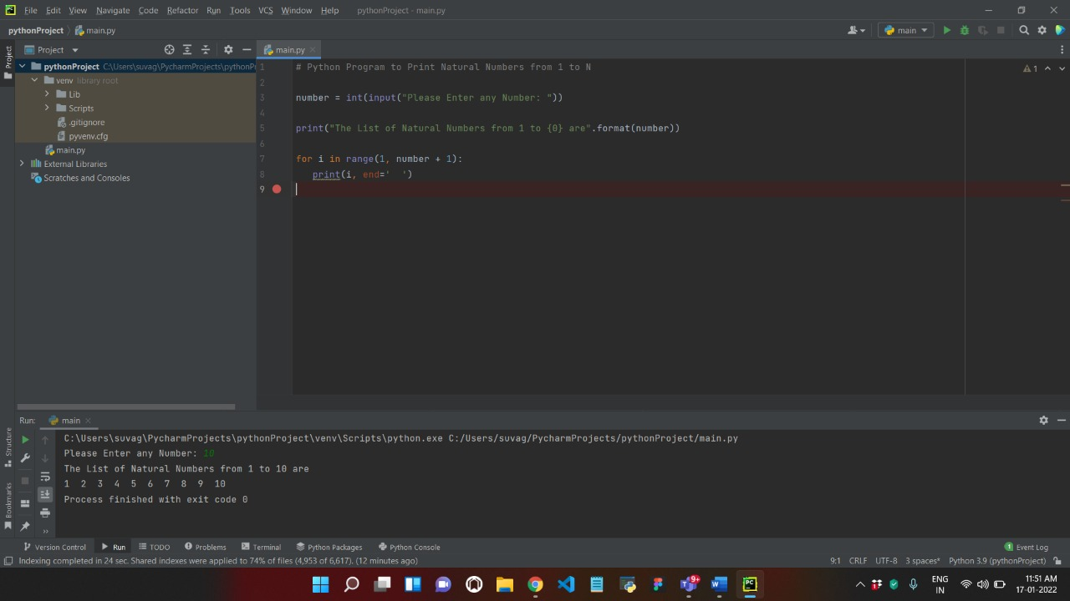

5. Python program for leap year

Code:

# Python program to check if year is a leap year or not

year = 2000

# To get year (integer input) from the user

# year = int(input("Enter a year: "))

# divided by 100 means century year (ending with 00)

# century year divided by 400 is leap year

if (year % 400 == 0) and (year % 100 == 0):

print("{0} is a leap year".format(year))

# not divided by 100 means not a century year

# year divided by 4 is a leap year

elif (year % 4 ==0) and (year % 100 != 0):

print("{0} is a leap year".format(year))

# if not divided by both 400 (century year) and 4 (not century year)

# year is not leap year

else:

print("{0} is not a leap year".format(year))

Output:

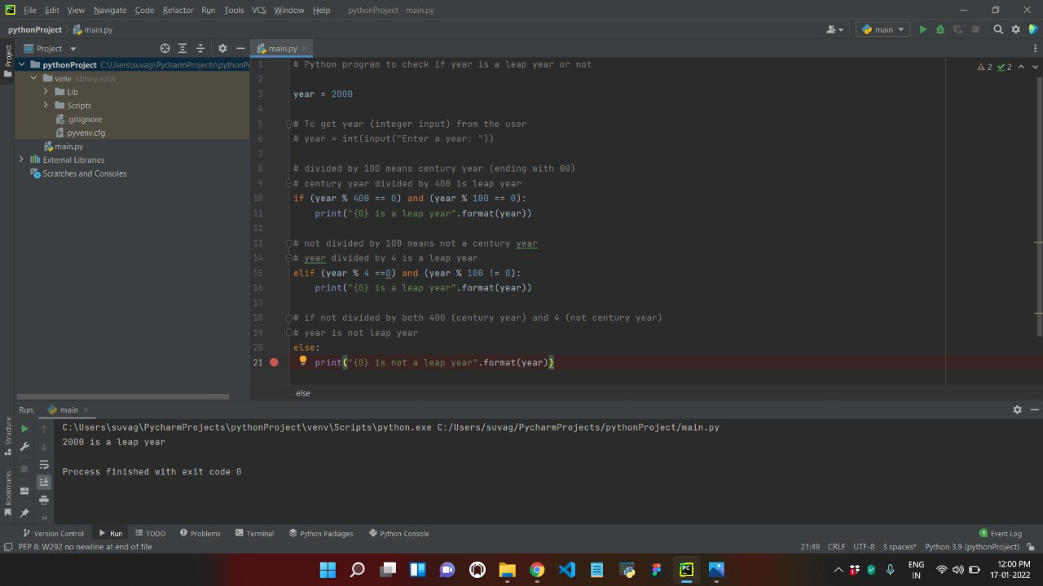

6.python program to find Odd or Even

Code:

# Python program to check if the input number is odd or even.

# A number is even if division by 2 gives a remainder of 0.

# If the remainder is 1, it is an odd number.

num = int(input("Enter a number: "))

if (num % 2) == 0:

print("{0} is Even".format(num))

else:

print("{0} is Odd".format(num))

Output:

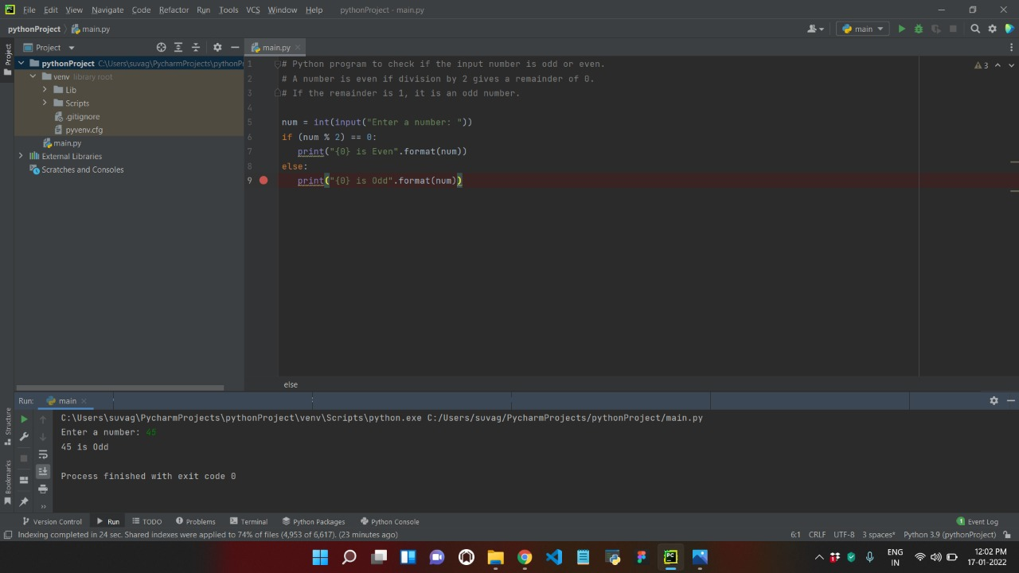

7. Python program to print Even Number from 1 to 100

Code:

# Python program to print Even Numbers in given range

start, end = 1, 100

# iterating each number in list

for num in range(start, end + 1):

# checking condition

if num % 2 == 0:

print(num, end = " ")

Output:

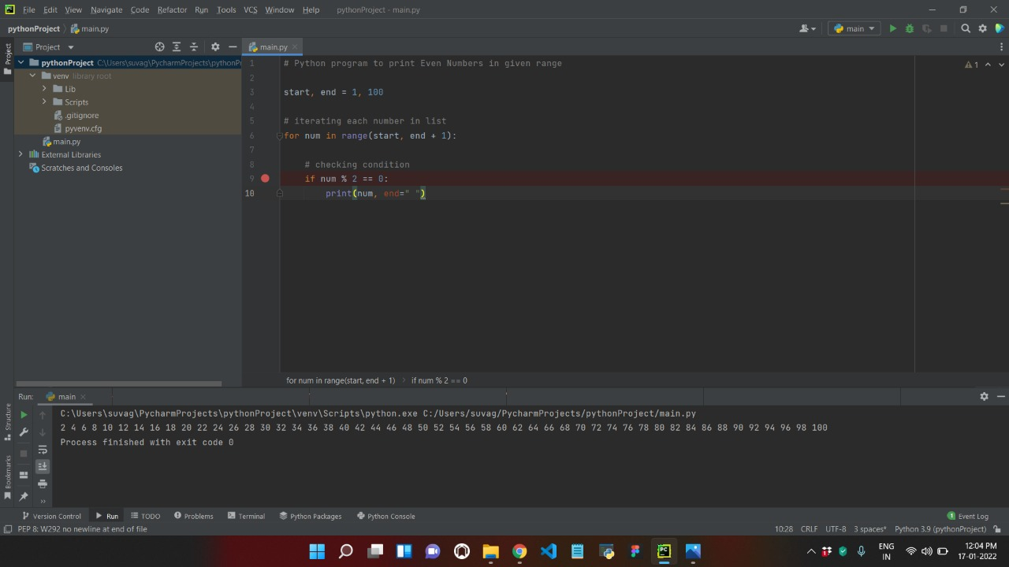

8.Python program to print Odd Number from 1 to 100

Code:

# Python program to print odd Numbers in given range

start, end = 1, 100

# iterating each number in list

for num in range(start, end + 1):

# checking condition

if num % 2 != 0:

print(num, end=" ")

Output:

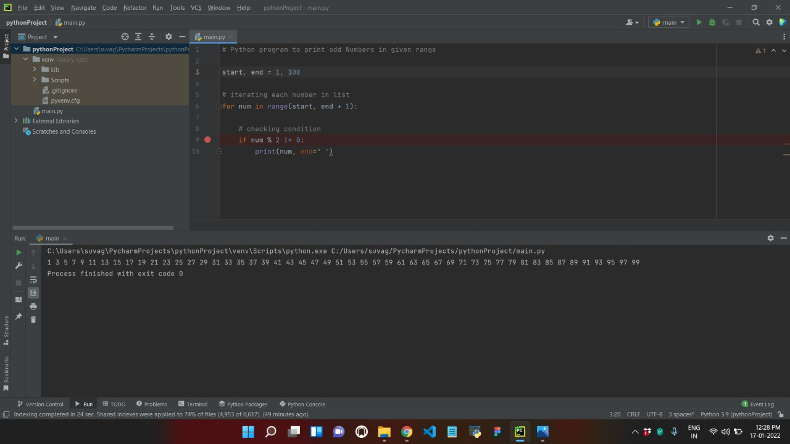

9.Python program to print Negative Number in a Range.

Code:

# Python program to print negative Numbers in given range

start, end = -4, 19

# iterating each number in list

for num in range(start, end + 1):

# checking condition

if num < 0:

print(num, end = " ")

Output:

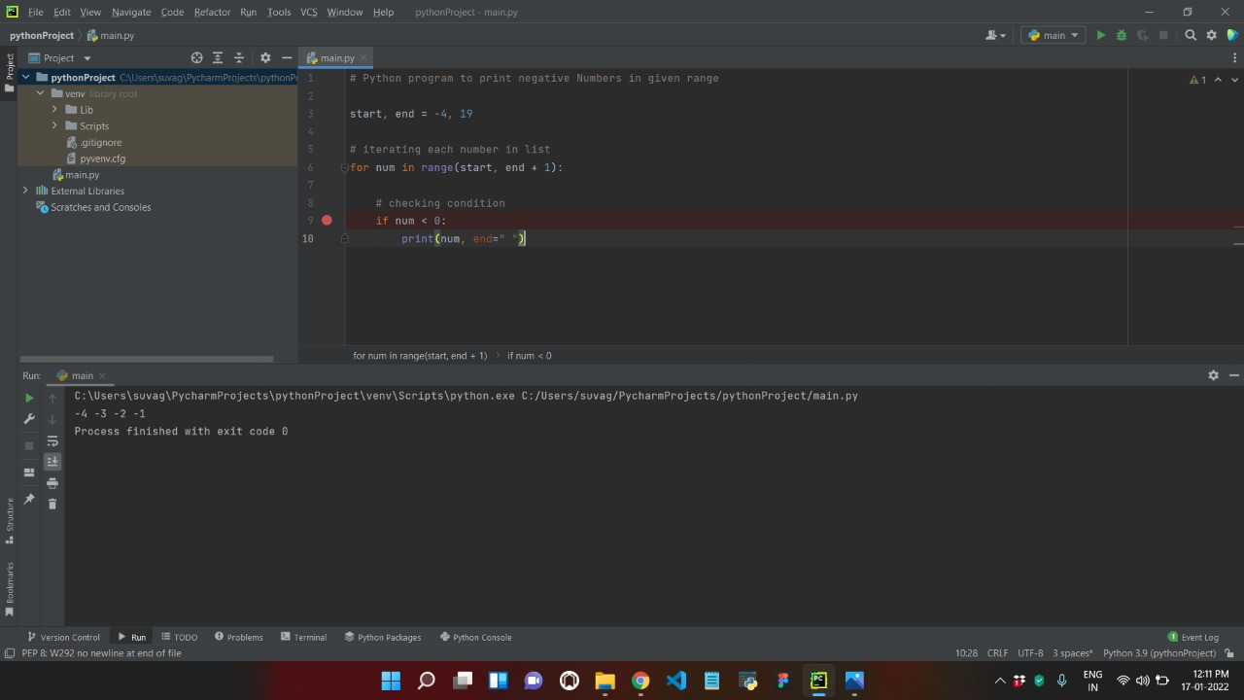

10.Python program to Print Positive Number in a Range.

Code:

# Python program to print positive Numbers in given range

start, end = -4, 19

# iterating each number in list

for num in range(start, end + 1):

# checking condition

if num >= 0:

print(num, end = " ")

Output:

